Escalating cases to development:

1. Login to the “Support Issues” project in Helix ALM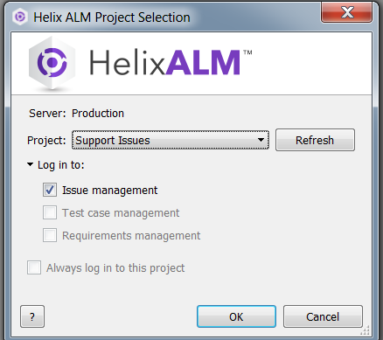
2. Go to View > Issues and add a new issue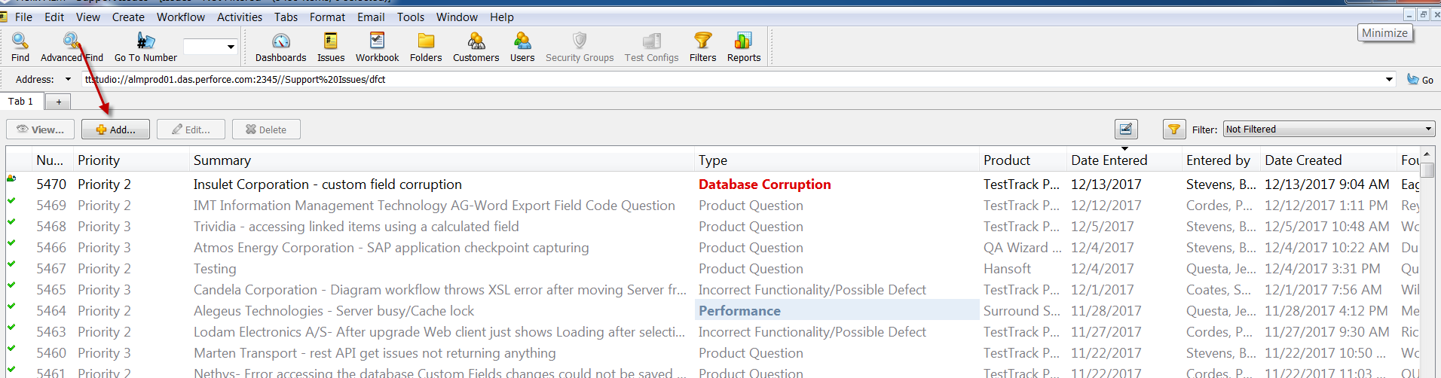
3. Enter all required information \*\*Include the company name in the summary of the issue\*\*  
   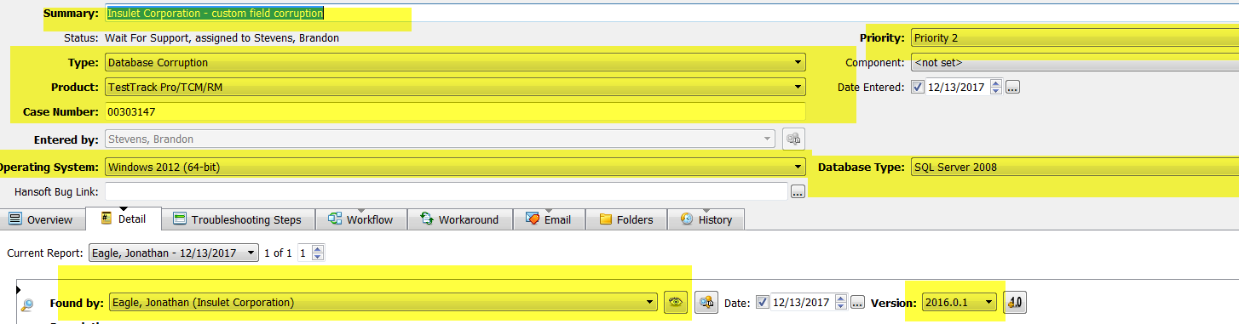
4. Include a detailed description of the problem and troubleshooting steps you have completed  
   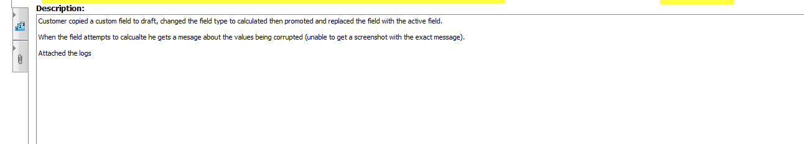

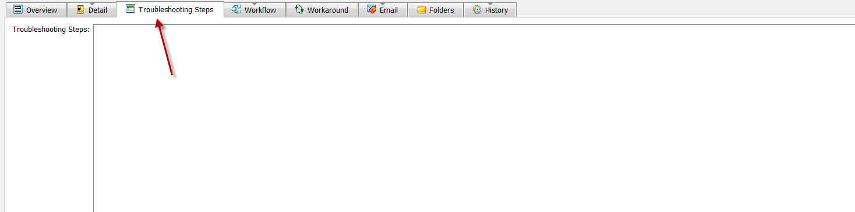

1. Include steps to reproduce the issue as well as the occurrence of the issue

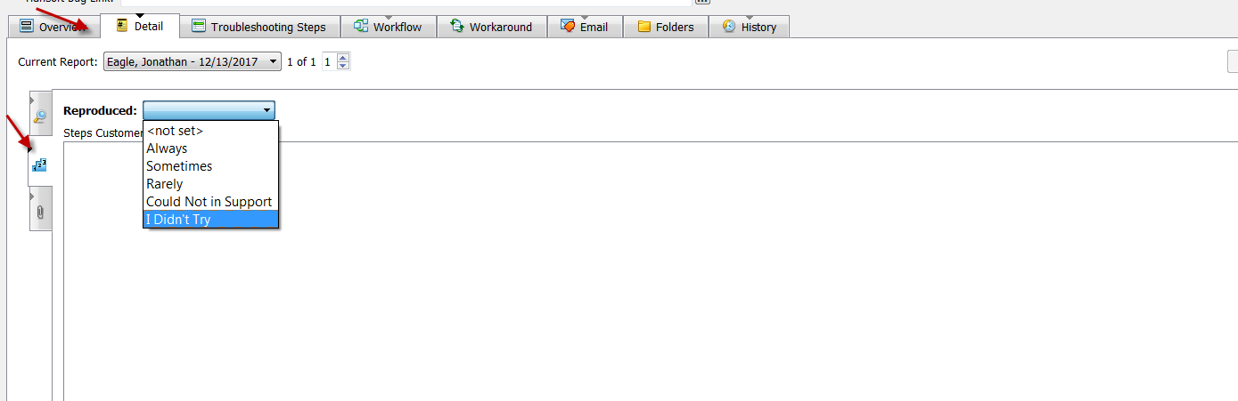

1. Once all information has been entered click the “OK” button to save the issue   
   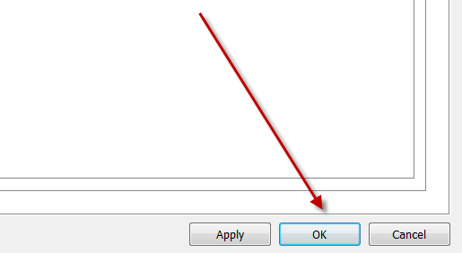

Issues are assigned to development managers based on the product. If the issue can be resolved in one response, the developer who is assigned the case will add a “Solution Provided” event to the issue with detailed steps to resolve the issue. Should this not resolve the issue the TSE can add an “Issue Not Resolved” event and add more detail for the developer.

When the issue cannot be resolved in one response or if the developer needs more information the “Request More Information” event is added to the issue with detailed information to get from the customer. Once this information is obtained the TSE adds an “Add Requested Information” event to the issue with the customer’s response.